This is from the Super Admin/Admin Side
Select Judge
Judge Name
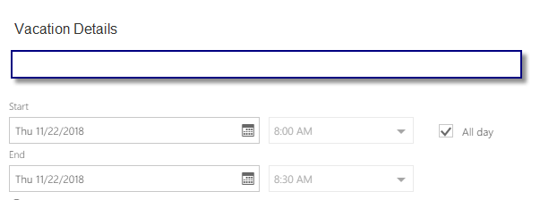

Records
Judge Name | Vacation Details | Start Date & Time | End Date & Time | All Day | Submitted Date & Time

------------------------------------------------------------------------------------------------------------------------------------------
From the Detective Side –
Judge Name – Bill Jones (On Call)
J. Brown
Alicia Johnson (Not Available)

